**Original Process document**

1. **Create a Local txt Document**

Create a txt document on your desktop, named ‘exercise.txt’.

1. **Initialize a Git Repository:**

2.1. Open the Terminal, and Navigate to the directory where "exercise.txt" is located:

Use “cd ~/Desktop” command.

Then use “ls” command to view the current contents of the directory.

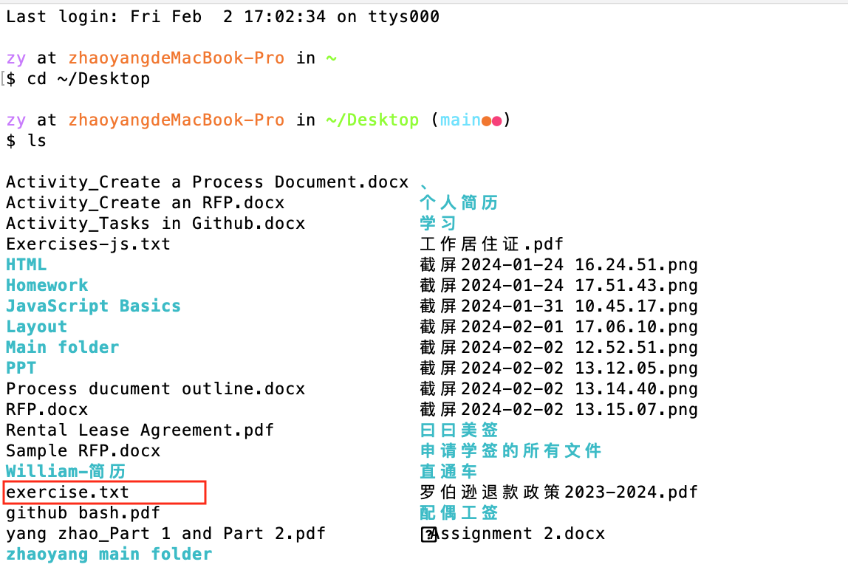

2.2. Initialize the Git repository.

Execute the command: git init

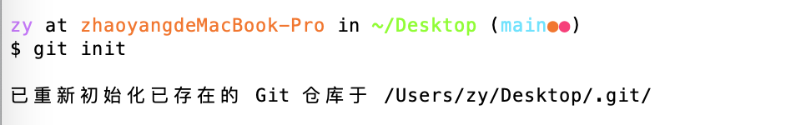

1. **Add some changes in txt.**

Open the txt with VS Code, and add some changes to exercise.txt.

1. **Use Git commands to stage changes**

**Problems encountered：**I stored exercise.txt on the desktop, but the terminal showed me the wrong path, it showed the txt was in my ‘JavaScript basics folder. Then I moved it to ‘yang_yang’ folder, and re-executed the command：



1. **Commit changes**

Execute the “git commit -m “Add exercise.txt” command to commit the changes:

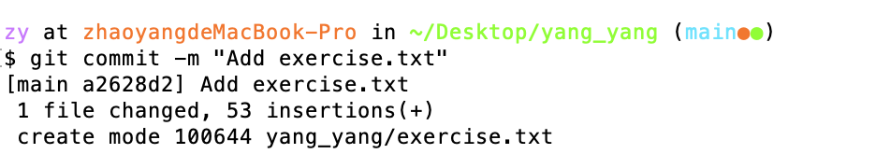

The changes have been committed and a commit log that contains the addition of "exercise.txt" has been created.

1. **Rollback to Initial Snapshot**

Execute the “git log” command to find the initial commit ID:

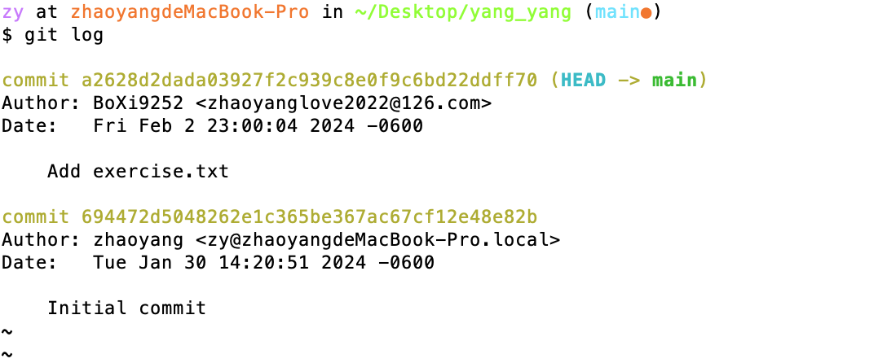

Execute the following command to rollback the initial snapshot:

git checkout <initial commit ID> -- exercise.txt

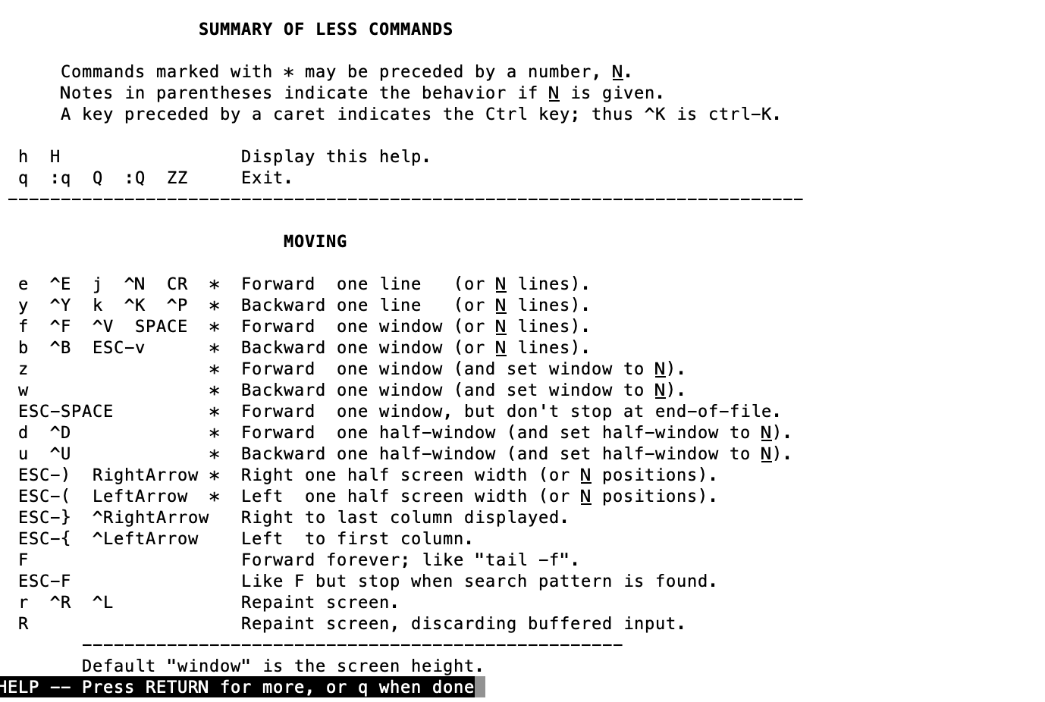

1. **Create a new repository on GitHub**

7.1. Log in GitHub and create a repository



7.2. Link local Git repository to the GitHub repository:

Find the URL in the GitHub repository, and copy the URL to the commit:

git remote add origin +URL



7.3. Push changes to GitHub:

Create the token on GitHub to meet the User Authentication.

7.4. Push local repository to remote repository on GitHub.

